複素空間上の円や螺旋：複素数のべき乗
１．複素数の積とドモアブルの定理
Products of Complex Numbers and De Moivre's Theorem
From Wikipedia, the free encyclopedia

In mathematics, de Moivre's formula (De Moivre's theorem and De Moivre's identity), named after Abraham de Moivre, states that for any complex number (and, in particular, for any real number) x and integer n it holds that
(cos x + i sin x)^n = cos (nx) + i sin (nx).

The process of mathematical induction can be used to prove a very important theorem in mathematics known as De Moivre's theorem. If the complex number z = r(cos α + i sin α), then
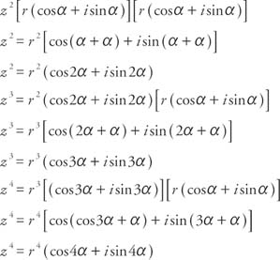

円分多項式 cyclotomic polynomial ：複素空間上のｎ角形
円周等分多項式或いは円分多項式と呼ばれる次の方程式、
x^n - 1 = 0
は、任意の n について、ベキ根と四則演算だけで解を求めることができる。
n=2 の場合= 根の公式
n=3 の場合=根の公式
n=4 の場合=明らか
n=5 の場合=１の５乗根。黄金数が出てくる。
n=7 の場合=３次方程式 カルダノの公式
n=17 の場合=２次方程式だけで解ける
計算方法は大変
x^5=1を解け
因数分解による方法
因数分解して
(x-1)(x^4+x^3+x^2+x+1)=0
左辺よりx=1
右のカッコ内をx^2≠0に注意してx^2で割ると
x^2+x+1+1/x+1/x^2=0となる。
これは相反方程式なので整理すると{(x+1/x)^2}-2+(x+1/x)+1=0
x^2+x=tとして整理するとt^2+t-1=0
因数分解してt=(-1±√5)/2となる。
x+1/x=tに戻して
x^2-((-1±√5)/2)x+1=0
2x^2-(-1±√5)x+2=0
再び解の公式に入れて x=[(-1+√5)±√(-10-2√5)]/4, [(-1-√5)±√(-10+2√5)]/4.
で, 2√5 < 10 だから, 虚数単位 i を用いると
x=[(-1±√5)±i√(10±2√5)]/4
(√5 の直前の複号だけ同順) となる。
ドモアブルの公式を使う方法
x=cosθ+i・sinθ とおく。
x^5=cos5θ+i・sin5θとなる。
cos5θ=1より、5θ=0+2nπ(nは整数)となる。θ=2nπ/1 n=1,2,3,4.5 の場合が解。
ド・モアブルの公式
整数nに対して、
(cosθ + isinθ)^n = cosnθ + i・sinθ
が成り立つという複素数に関する定理である
アブラーム・ド・モアブル（Abraham de Moivre, 1667 - 1754年）はフランスの数学者である。
２．指数関数の４つの定義
The four most common definitions of the exponential function exp(x) = e^{x} for real x are:
1. Define e^{x} by the limit
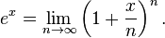
2. Define e^{x} as the value of the infinite series
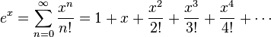
(Here n! denotes the factorial of n. One proof that e is irrational uses this representation.)
3. Define e^{x} to be the unique number y > 0 such that
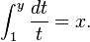
This is as the inverse of the natural logarithm function, which is defined by this integral.
4. Define e^{x} to be the unique solution to the initial value problem
(Here, y′ denotes the derivative of y.)
３．指数関数の複素領域への拡張：オイラーの恒等式
指数関数と三角関数の間に成り立つ等式
オイラーの公式の幾何的な表示をいう。ここに、θ は幾何学的には弧度法に従う角と見なされる実変数である
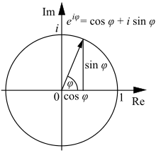
The exponential function e^{x} for real values of x may be defined in a few different equivalent ways . Several of these methods may be directly extended to give definitions of e^{z} for complex values of z simply by substituting z in place of x and using the complex algebraic operations. In particular we may use either of the two following definitions which are equivalent.

Power series definition
For complex z
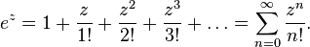
Using the ratio test it is possible to show that this power series has an infinite radius of convergence, and so defines e^{z} for all complex z.
Limit definition
For complex z
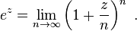
3通りの証明：Proofs
Various proofs of the formula are possible.
１）Using power series
Here is a proof of Euler's formula using power series expansions as well as basic facts about the powers of i:
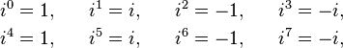
and so on. Using now the power series definition from above we see that for real values of x
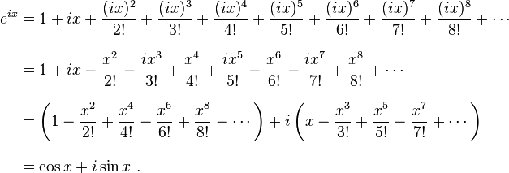
In the last step we have simply recognized the Maclaurin series for cos(x) and sin(x). The rearrangement of terms is justified because each series is absolutely convergent.
２）Using the limit definition
The exponential function e^{z} can be defined as the limit of(1 + z/n)^{n}, as n approaches infinity. In this animation, z=iπ/3, and n takes various increasing values from 1 to 100. The computation of (1 + z/n)^{n}is displayed as the combined effect ofn repeated multiplications in thecomplex plane. As n gets larger, the points approach the complex unit circle (dashed line), covering an angle of π/3 radians.
An alternative proof is based on the limit definition of :
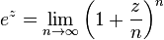.
Substitute , and let n be a very large integer, say 1000. Then, based on the limit definition, the complex number (1+ix/1000)¹⁰⁰⁰ is supposed to be a good approximation to e^{ix}. So, what is the value of (1+ix/1000)¹⁰⁰⁰?
Consider the sequence of 1000 complex numbers:
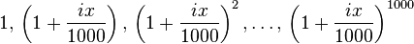
(We started with 1, and successively multiplied it by (1+ix/1000), 1000 times.) If the points of this sequence are plotted in the complex plane (see animation at right), they approximately trace out the unit circle, with each point being x/1000 radians counterclockwise of the previous point. (The proof of this is based on the rules of trigonometry and complex-number algebra.) Therefore, the last point in the sequence,(1 + ix/1000)¹⁰⁰⁰, is approximately the point on the unit circle of the complex planelocated x radians counterclockwise from +1, that is the point cos x + i sin x. If we replaced the number 1000 by larger and larger numbers, all of the approximations in this paragraph become more and more accurate. Therefore, e^{ix} = cos x + i sin x.
３）Using calculus：微分を用いた証明
Another proof^{[7]} is based on the fact that all complex numbers can be expressed in polar coordinates. Therefore for some and depending on ,
Now from any of the definitions of the exponential function it can be shown that the derivative of is . Therefore differentiating both sides gives
Substituting for and equating real and imaginary parts in this formula gives and . Together with the initial values and which come from this gives and . This proves the formula .
三角関数の指数関数表現
この公式は、全く起源の異なる指数関数と三角関数が複素数の世界では密接に結びついていることを示していると見ることができる。たとえば三角関数の加法定理は、指数法則 eªe^{b} = e^{a+b} に対応していることが分かる。さらに
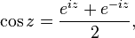
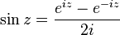
と置き換えることで、初等関数は全て指数関数の一部であると見なすこともできる。
初等関数とは、複素数を変数とする多項式関数・指数関数・対数関数主値の四則演算・合成によって表示できる関数である。これによると、三角関数や双曲線関数、そして両者の逆関数主値も
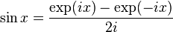
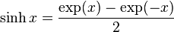
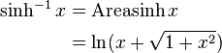
に代表される表示が可能であるから、初等関数と考えることが出来る。
初等関数の導関数は必ず初等関数になる.
- 連続回微分可能な初等関数は、ある点の周りで多項式で近似できる。このような多項式展開を、マクローリン展開とかテーラー展開と呼ばれる。

- 三角関数と指数関数は，次のようにテイラー展開できる．
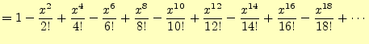
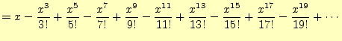
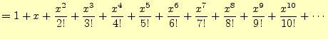

ある関数が、下記の式で表すことができるとしよう
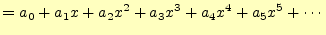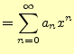
．は三角関数であったり，指数関数，あるいは対数関数である．この式の左辺は，冪級数と呼ぶ．この式は，任意の関数を冪球数に展開して いるのである．
任意の関数が式のように冪級数に展開できるならば，そ の係数をどうやって決めるのか?元の式，お よびその両辺を繰り返し微分すると次の式が得られる．
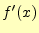 | 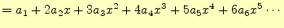
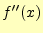
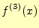
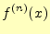 | 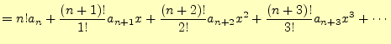

これらの式でとすると，右辺第2項より高次の項は全てゼロとなる．これを利用して， 式(7)の展開係数は
 |  |  | 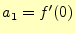 |  | 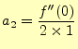 |  | 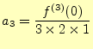 |  |  |  | 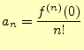
と得られる．とすると，最後の式である 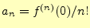がを含めて一般的 に成り立つ．整理すれば
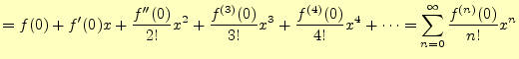
となる．これで，任意の関数を冪級数で展開する方法が分かった
任意の関数は，冪級数に展開できる． マクローリン展開はゼロの周りで近似。
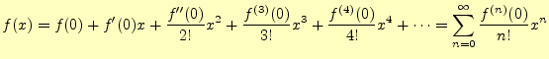

三角関数の原点回りでの多項式近似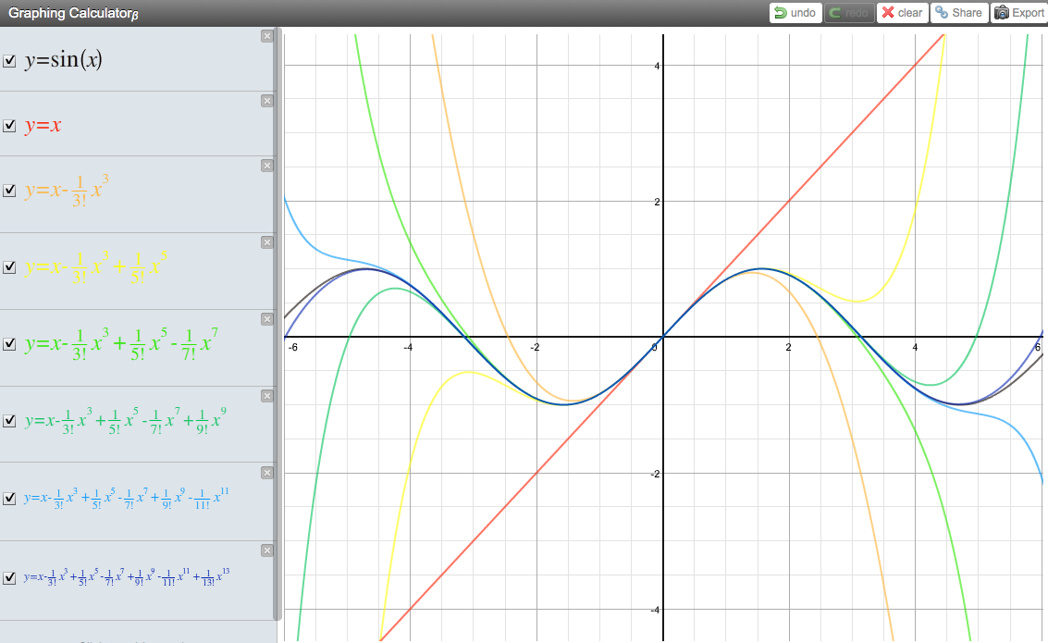

付録：Appendix
Proof of e^(ix) = cos(x) + isin(x)

From: Walter Graf

Subject: Proof of e^(ix) = cos(x) + isin(x)

In the equation e^(iPi) - 1 = 0, the proof is to evaluate

e^(ix) = cos(x) + isin(x) for x = Pi.

I would like to see a rigorous proof of of the the above equation. Thank you,
From: Doctor Mitteldorf
Subject: Re: Proof of e^(ix) = cos(x) + isin(x)

Dear Walter,

This is called the Euler equation, and it's not something you can prove rigorously. It's a definition, and I'd like to convince you that it's the only sensible definition, of how to compute imaginary exponentials.

I can think of three approaches to verifying the Euler equation, but unfortunately one of them is all calculus, one uses calculus explicitly, and only the third is free of calculus. I'm just guessing from your age that you may not have studied calculus yet.

You can verify that the Euler equation makes a sensible definition by expanding the two sides as Taylor series in x. You can also differentiate both sides and see that the answer is self-consistent.

Thirdly, you can use the formula for cos(2x) and sin(2x) to show that the right side has the property you expect from an exponential, so

that e^i(2x) = (e^ix)^2.

So start with choice 3. You have the formulas

cos(2x) = cos^2(x) - sin^2(x) and
sin(2x) = 2 sin(x) cos(x)

You'd also want to demand that e^i(2x) = (e^ix)^2. That means that your new definition of e^ix is behaving like an exponential. See if you can put these together to show that

e^i(2x) = cos (2x) + i sin(2x).

The Taylor expansion is something you can appreciate without calculus, although its roots are in calculus. It's a series expression for a function. You may have run across the following infinite series representations of cos and sin and e^x. In fact, this is the most straightforward way to compute the value of sin(x) or e^x for any

given x.

cos(x) = 1 - x^2/2! + x^4/4! - x^6/6! + ...

sin(x) = x - x^3/3! + x^5/5! - x^7/7! + ...

e^x = 1 + x + x^2/2! + x^3/3! + x^4/4! + ...
The ! in these equations means factorial. In other words,

4! = 4*3*2*1.

See if you can use these infinite series expressions to verify the Euler equation.

-Doctor Mitteldorf, The Math Forum

Check out our web site! http://mathforum.org/dr.math/
Euler Equation and DeMoivre's Theorem

